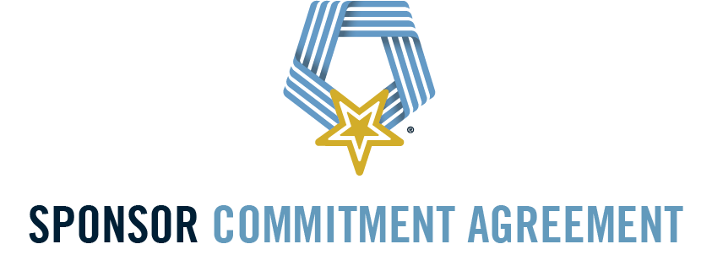

We / I, _________________________, hereby commit a total contribution of $50,000 to the National Medal of Honor Museum Foundation in support of the Foundation’s ongoing campaign to sustain operations, educational programming, and mission-driven initiatives.

This gift will help ensure the long-term success of the Museum’s efforts to educate, inspire, and engage future generations through impactful programming and enduring experiences that honor the values embodied by the Medal of Honor.

Payment Schedule:

One-time payment: Full contribution to be received on or before ______________ (date)

_______________________ ______________
Sponsor Signature Date

_______________________ ______________
Chris Cassidy, President & CEO Date
National Medal of Honor Museum Foundation

Please return this Sponsor Commitment Agreement via email to jgarrett@mohmuseum.org or mail it to the following address:

National Medal of Honor Museum Foundation
Attention: Julianne Garrett, Senior Director of Development
1717 E. Randol Mill Road, Suite 301
Arlington, Texas 76011



PRIMARY CONTACT

Name(s): _____________________________ ______________________________
(Last) (First)

Name(s): ____________________ _________________ _______________ _______
(Street) (City) (State) (ZIP)

Email(s): ________________________________ ________________________________

Phone Number: __________________________

SECONDARY CONTACT

Name(s): _____________________________ ______________________________
(Last) (First)

Name(s): ____________________ _________________ _______________ _______
(Street) (City) (State) (ZIP)

Email(s): ________________________________ ________________________________

Phone Number: __________________________

Sign:

______________________________ _______________________
(Sponsor Signature) (Date)

Please return this Sponsor Commitment Agreement via email to jgarrett@mohmuseum.org or mail it to the following address:

National Medal of Honor Museum Foundation
Attention: Julianne Garrett, Senior Director of Development
1717 E. Randol Mill Road, Suite 301
Arlington, Texas 76011
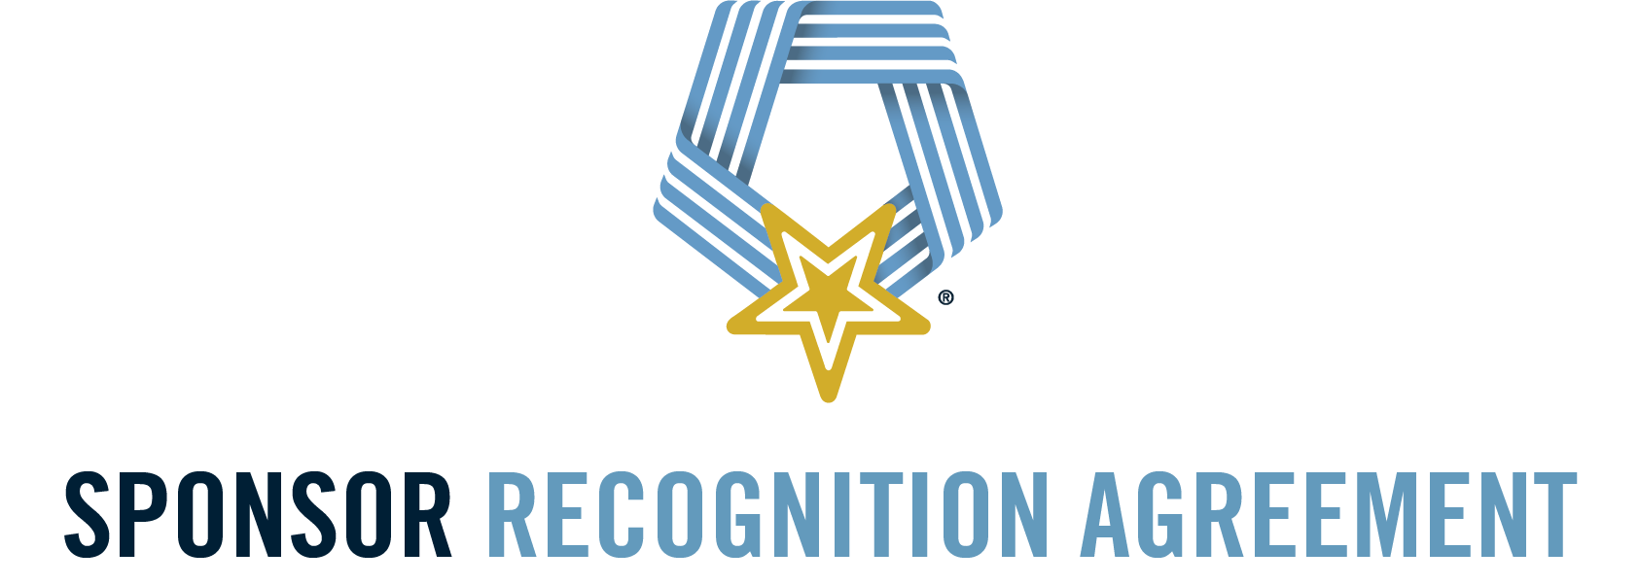

Thank you for your generous commitment to the National Medal of Honor Museum Foundation.

As a valued supporter, we want to ensure your gift is acknowledged in accordance with your preferences. For all donors contributing $10,000 or more, recognition will be provided in perpetuity within the Museum or affiliated publications, as a lasting testament to your support and the values we honor.

Please indicate below how you would like your name(s) to appear in donor recognition materials:

- I/We would like to be publicly acknowledged. Please display my/our name(s) as follows:
_____________________________________________________________
(please print clearly how you would like your name(s) recognized)
- I/We prefer to remain anonymous and decline public recognition.

By signing below, I/we authorize the National Medal of Honor Museum Foundation to recognize (or not recognize) our gift as indicated above.

_______________________ ______________
Sponsor Signature Date

_______________________ ______________
Chris Cassidy, President & CEO Date
National Medal of Honor Museum Foundation

Please return this Sponsor Commitment Agreement via email to jgarrett@mohmuseum.org or mail it to the following address:

National Medal of Honor Museum Foundation
Attention: Julianne Garrett, Senior Director of Development
1717 E. Randol Mill Road, Suite 301
Arlington, Texas 76011
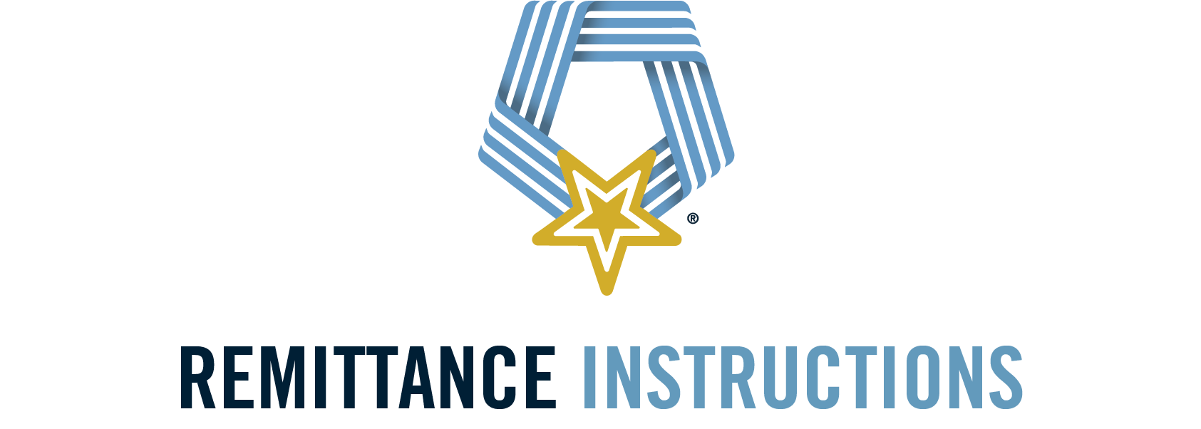

WIRE / ACH
Bank Name: Texas Capital Bank
Account Name: National Medal of Honor Museum
Account #: 2400084020
Wire Transfer Routing #: 111017979
ACH Transfer Routing #: 111017979
Bank Address: Texas Capital Bank
5800 Granite Parkway Suite 150
Plano, Texas 75024

CHECK
Please make check payable to: The National Medal of Honor Museum
Mailing Address: Attn: Julianne Garrett
1717 E Randol Mill Road, Suite 301
Arlington, TX 76011

CREDIT CARD
If you would like to pay with a credit card, please contact Julianne Garrett at (713) 304-6476. Service fees will be added for this payment method.
A 5% processing fee will be added to all credit card transactions.

CONTACT INFORMATION
Prior to making any remittance, please call Betsy Eudy, CFO, at (817) 980-2138 for banking verification.

1717 East Randol Mill Road | Suite301
Arlington, TX 76011

**Please be aware of the rise in online banking fraud. If you receive an email with wire transfer instructions or asking you to send funds to anyone, do not rely solely on email for confirmation. Always call us directly to verify the legitimacy of the request and ensure your funds are secure.**

